**Mini-Project Report**

**Name – Swaraj Santosh Pawar**

**Employee ID – 5852**

**Mini-Project on Online Learning Platform**

**Problem Statement**

Existing educational methods lack accessibility, engagement, and personalization, while technology gaps hinder effective remote learning. An innovative online platform is needed to provide an inclusive, dynamic, and interactive learning experience for students and educators. While making website we are using HTML, CSS & JAVASCRIPT.

**Understanding**

The problem is that current ways of learning face issues like limited access to quality education, low engagement, and a lack of personalization. Also, with the shift to remote learning, there are technology gaps affecting effective education. The solution needed is a new online platform that offers an inclusive, dynamic, and interactive learning experience for both students and educators.

**Introduction**

Online learning, or e-learning, denotes the utilization of digital technologies, particularly the internet, to administer educational content and facilitate learning experiences. It represents a paradigm shift in educational delivery mechanisms, moving away from traditional brick-and-mortar classrooms to virtual environments. Technical aspects of online learning encompass:

1. **Internet-based Infrastructure:** Online learning is fundamentally reliant on robust internet connectivity. The delivery of educational content, interactive elements, and collaborative tools is made possible through online platforms, transcending the constraints of physical classrooms.
2. **Asynchronous Learning Models:** A hallmark of online learning is its asynchronous nature, allowing learners to access course materials and engage with educational content at their own pace. This flexibility is particularly advantageous for adult learners, working professionals, and those seeking personalized learning experiences.
3. **Multimodal Instructional Design:** Online learning environments employ a rich array of multimedia resources, including textual content, video lectures, interactive simulations, and assessments. This multimodal approach caters to diverse learning preferences, fostering an immersive and engaging educational experience.
4. **Communication Protocols:** Online learning platforms facilitate communication and collaboration through diverse channels. Features such as discussion forums, live chat, video conferencing, and email enable seamless interaction between students and instructors, despite physical distances.
5. **Automated Assessment Tools:** Assessment in online learning is often facilitated through automated tools such as quizzes, assignments, and exams embedded within the digital platform. These tools not only streamline the evaluation process but also provide instant feedback to learners, promoting continuous improvement.
6. **Global Connectivity:** A distinctive feature of online learning is its borderless accessibility. Learners from various geographic locations can partake in educational programs, fostering a globally interconnected learning community. This inclusivity enhances the richness of perspectives and cultural diversity within the virtual classroom.

Online learning has evolved into a prominent educational paradigm, finding application in formal academic institutions, professional certifications, and corporate training initiatives. Its technical intricacies underscore its transformative potential, offering not only flexibility but also expanding the horizons of education beyond traditional constraints.

**Why we Need Online Learning**

1. **Accessibility:** Many individuals face barriers to accessing quality education due to geographical constraints, economic limitations, or other factors. An online learning platform can break down these barriers by providing education to a diverse and global audience.
2. **Flexibility:** Traditional classroom settings may not cater to the varying pace and schedules of learners. An online learning platform allows individuals to learn at their own pace, offering flexibility in terms of timing and duration of study sessions.
3. **Personalization:** Every learner is unique, with different strengths, weaknesses, and learning styles. Online learning platforms can incorporate adaptive technologies, personalized content, and interactive methods to cater to individual learning needs.
4. **Remote Learning**: The recent trend towards remote work and education has highlighted the importance of having a robust online learning infrastructure. An online platform allows for seamless remote learning, ensuring continuity in education during unexpected disruptions.
5. **Cost-Efficiency**: Traditional education often involves high costs related to commuting, accommodation, and physical resources. Online learning platforms can be more cost-effective, making education more affordable and accessible to a broader demographic.
6. **Technological Integration**: The digital age demands a more technologically integrated approach to education. Online learning platforms leverage technology to enhance the learning experience, promote digital literacy, and prepare individuals for the demands of the modern workforce.
7. **Continuous** **Learning:** Lifelong learning is becoming increasingly essential in today's fast-paced world. An online learning platform facilitates continuous learning by offering a variety of courses and resources that can be accessed throughout one's career.

**ALGORITHM**

1. **Define the Structure:**

* Create an HTML document outlining the structure of the webpage.
* Include sections for the header, navigation, main content area (courses), and footer.

1. **Styling with CSS:**

* Implement a basic CSS stylesheet to style the website.
* Design the header, navigation bar, course cards, and footer for a visually appealing layout.

1. **Header and Navigation:**

* Include a header with the website's title.
* Add a navigation bar with links for Home, Courses, About Us, and Contact.

1. **Course Display:**

* Create a section to display courses.
* Define the layout for displaying course information, such as title, instructor, and duration.
* For each course, consider using a card or a similar visual element.

1. **Dynamic Content Loading (JavaScript):**

* Use JavaScript to dynamically load course data onto the webpage.
* Fetch course information from a predefined data source or an API.
* Populate the course section with dynamically generated content.

1. **Enrolment Functionality:**

* Implement a function in JavaScript to handle course enrollment.
* This function could display a confirmation message or prompt users to log in if authentication is required.

1. **Responsiveness:**

* Ensure the website is responsive to different screen sizes and devices using media queries in CSS.
* Optimize the layout for both desktop and mobile users.

1. **Footer:**

* Design a footer with relevant information, such as copyright details or links to additional resources.

1. **Testing:**

* Test the website on various browsers to ensure cross-browser compatibility.
* Verify that the website is functional and user-friendly on different devices.

1. **Optimization:**

* Optimize the website for performance, considering factors such as image compression and code minification.

1. **Deployment:**

* Deploy the website on a web server or hosting platform to make it accessible to users.

This algorithmic outline provides a step-by-step guide for creating a basic online learning platform website. Depending on the specific requirements, additional features and considerations may be necessary for a fully functional and secure platform.

**HTML CODE**

**Index.html**

<!DOCTYPE html>

<html lang="en">

  <head>

    <meta charset="UTF-8" />

    <meta name="viewport" content="width=device-width, initial-scale=1.0" />

    <title>HOME</title>

    <script src="https://cdnjs.cloudflare.com/ajax/libs/flowbite/2.2.0/flowbite.min.js"></script>

    <link

      href="https://cdnjs.cloudflare.com/ajax/libs/flowbite/2.2.0/flowbite.min.css"

      rel="stylesheet"

    />

    <link href="./index.css" rel="stylesheet" />

    <script defer src="./script.js"></script>

  </head>

  <body>

    <!--navbar-->

    <nav class="bg-white border-gray-200 dark:bg-gray-900">

      <div

        class="flex flex-wrap justify-between items-center mx-auto max-w-screen-xl p-4"

      >

        <a

          class="flex items-center space-x-3 rtl:space-x-reverse"

        >

          <img

            src="Images/Logo.png"

            class="logo"

            alt="Flowbite Logo"

            loading="eager"

          />

          <span

            class="self-center text-2xl font-bold whitespace-nowrap dark:text-white"

            >TechSpark</span

          >

        </a>

        <div class="max-w-screen-xl px-4 py-3 mx-auto">

          <div class="flex items-center">

            <ul

              class="flex flex-row font-medium mt-0 space-x-8 rtl:space-x-reverse text-sm"

            >

              <li>

                <a

                  href="#"

                  class="text-gray-900 dark:text-white hover:underline"

                  aria-current="page"

                  >Home</a

                >

              </li>

              <li>

                <a

                  id="dropdownDividerButton"

                  data-dropdown-toggle="dropdownDivider"

                  class="text-black bg-transparent focus:ring-4 focus:outline-none focus:ring-blue-300 font-medium rounded-lg text-sm text-center inline-flex items-center bg-blue-600 dark:hover:bg-blue-700 dark:focus:ring-blue-800"

                  type="button"

                >

                  Courses

                  <svg

                    class="w-3 h-3 ms-3"

                    aria-hidden="true"

                    xmlns="http://www.w3.org/2000/svg"

                    fill="none"

                    viewBox="0 0 10 6"

                  >

                    <path

                      stroke="currentColor"

                      stroke-linecap="round"

                      stroke-linejoin="round"

                      stroke-width="2"

                      d="m1 1 4 4 4-4"

                    />

                  </svg>

                </a>

                <!-- Dropdown menu -->

                <div

                  id="dropdownDivider"

                  class="z-10 hidden bg-white divide-y divide-gray-100 rounded-lg shadow w-44 dark:bg-gray-700 dark:divide-gray-600"

                >

                  <ul

                    class="py-2 text-sm text-gray-700 dark:text-gray-200"

                    aria-labelledby="dropdownDividerButton"

                  ></ul>

                  <div class="py-2">

                    <a

                      href="#it"

                      class="block px-4 py-2 text-sm text-gray-700 hover:bg-blue-100 dark:text-gray-200 dark:hover:text-white"

                      >Information Technology</a

                    >

                  </div>

                  <div class="py-2">

                    <a

                      href="#mech"

                      class="block px-4 py-2 text-sm text-gray-700 hover:bg-blue-100 dark:hover:bg-gray-600 dark:text-gray-200 dark:hover:text-white"

                      >Mechanical</a

                    >

                  </div>

                  <div class="py-2">

                    <a

                      href="#mba"

                      class="block px-4 py-2 text-sm text-gray-700 hover:bg-blue-100 dark:hover:bg-gray-600 dark:text-gray-200 dark:hover:text-white"

                      >MBA</a

                    >

                  </div>

                  <div class="py-2">

                    <a

                      href="#chemical"

                      class="block px-4 py-2 text-sm text-gray-700 hover:bg-blue-100 dark:hover:bg-gray-600 dark:text-gray-200 dark:hover:text-white"

                      >Chemical</a

                    >

                  </div>

                  <div class="py-2">

                    <a

                      href="#civil"

                      class="block px-4 py-2 text-sm text-gray-700 hover:bg-blue-100 dark:hover:bg-gray-600 dark:text-gray-200 dark:hover:text-white"

                      >Civil</a

                    >

                  </div>

                </div>

              </li>

              <li>

                <a

                  href="#about"

                  class="text-gray-900 dark:text-white hover:underline"

                  >About us</a

                >

              </li>

            </ul>

          </div>

        </div>

        <div class="flex items-center space-x-6 rtl:space-x-reverse">

          <img

            src="Images/Phone logo-modified.png"

            class="phn_logo"

            loading="eager"

          />

          <a

            href="tel:5541251234"

            class="text-sm text-gray-500 dark:text-white hover:underline"

            >(+91) 9483123489</a

          >

        </div>

      </div>

    </nav>

    <nav class="bg-gray-50 dark:bg-gray-700"></nav>

    <!---->

    <!--Hero-->

    <section class="bg-center bg-no-repeat">

      <div class="px-4 mx-auto max-w-screen-xl text-center py-24 lg:py-56">

        <h1

          class="mb-4 text-4xl font-extrabold tracking-tight leading-none text-white md:text-5xl lg:text-6xl"

        >

        "Innovative learning tech solutions that inspire growth and achievement in every student."

        </h1>

        <!-- <p

          class="mb-8 text-lg font-bold  text-gray-600 lg:text-xl sm:px-16 lg:px-48"

        >

          Here at Flowbite we focus on markets where technology, innovation, and

          capital can unlock long-term value and drive economic growth.

        </p> -->

        <div

          class="flex flex-col space-y-4 sm:flex-row sm:justify-center sm:space-y-0"

        >

        </div>

      </div>

    </section>

    <!---->

    <!--IT-->

    <div class="bg-orange-100 w-screen" id="it" style="padding: 4em">

      <h1

        class="mb-8 text-3xl font-extrabold text-gray-700 dark:text-white md:text-5xl lg:text-6xl"

      >

        <span

          class="text-transparent bg-clip-text bg-gradient-to-r to-emerald-600 from-sky-400"

          >Information Technology</span

        >

      </h1>

      <div class="flex flex-row gap-8 px-8 py-8 overflow-x-auto divx">

        <div

          class="w-96 cd bg-white border border-gray-200 rounded-lg shadow dark:bg-gray-800 dark:border-gray-700"

        >

          <a href="#">

            <img

              class="rounded-t-lg"

              src="https://res.cloudinary.com/dkvwkfzfn/image/upload/v1702711442/online-learning/AI_q5lmbi.jpg"

              alt=""

              loading="eager"

            />

          </a>

          <div class="p-5">

            <a href="#">

              <h5

                class="mb-2 text-2xl font-bold tracking-tight text-gray-900 dark:text-white"

              >

                Artificial Intelligence

              </h5>

            </a>

            <p class="mb-3 font-normal text-gray-700 dark:text-gray-400">

              Here are the biggest enterprise technology acquisitions of 2021 so

              far, in reverse chronological order.

            </p>

            <a

              onclick="changePage(this.id)"

              id="btn00"

              class="btn cursor-pointer inline-flex items-center px-3 py-2 text-sm font-medium text-center text-white bg-blue-700 rounded-lg hover:bg-blue-800 focus:ring-4 focus:outline-none focus:ring-blue-300 dark:bg-blue-600 dark:hover:bg-blue-700 dark:focus:ring-blue-800"

            >

              Explore more

              <svg

                class="rtl:rotate-180 w-3.5 h-3.5 ms-2"

                aria-hidden="true"

                xmlns="http://www.w3.org/2000/svg"

                fill="none"

                viewBox="0 0 14 10"

              >

                <path

                  stroke="currentColor"

                  stroke-linecap="round"

                  stroke-linejoin="round"

                  stroke-width="2"

                  d="M1 5h12m0 0L9 1m4 4L9 9"

                />

              </svg>

            </a>

          </div>

        </div>

        <div

          class="w-96 cd bg-white border border-gray-200 rounded-lg shadow dark:bg-gray-800 dark:border-gray-700"

        >

          <a href="#">

            <img

              class="rounded-t-lg"

              src="https://res.cloudinary.com/dkvwkfzfn/image/upload/v1702711444/online-learning/Data_Scientiest_nisgkw.jpg"

              alt=""

              loading="eager"

            />

          </a>

          <div class="p-5">

            <a href="#">

              <h5

                class="mb-2 text-2xl font-bold tracking-tight text-gray-900 dark:text-white"

              >

                Data Science

              </h5>

            </a>

            <p class="mb-3 font-normal text-gray-700 dark:text-gray-400">

              Here are the biggest enterprise technology acquisitions of 2021 so

              far, in reverse chronological order.

            </p>

            <a

              onclick="changePage(this.id)"

              id="btn01"

              class="btn cursor-pointer inline-flex items-center px-3 py-2 text-sm font-medium text-center text-white bg-blue-700 rounded-lg hover:bg-blue-800 focus:ring-4 focus:outline-none focus:ring-blue-300 dark:bg-blue-600 dark:hover:bg-blue-700 dark:focus:ring-blue-800"

            >

              Explore more

              <svg

                class="rtl:rotate-180 w-3.5 h-3.5 ms-2"

                aria-hidden="true"

                xmlns="http://www.w3.org/2000/svg"

                fill="none"

                viewBox="0 0 14 10"

              >

                <path

                  stroke="currentColor"

                  stroke-linecap="round"

                  stroke-linejoin="round"

                  stroke-width="2"

                  d="M1 5h12m0 0L9 1m4 4L9 9"

                />

              </svg>

            </a>

          </div>

        </div>

        <div

          class="w-96 cd bg-white border border-gray-200 rounded-lg shadow dark:bg-gray-800 dark:border-gray-700"

        >

          <a href="#">

            <img

              class="rounded-t-lg"

              src="https://res.cloudinary.com/dkvwkfzfn/image/upload/v1702711445/online-learning/Java_gxp1hd.jpg"

              alt=""

              loading="eager"

            />

          </a>

          <div class="p-5">

            <a href="#">

              <h5

                class="mb-2 text-2xl font-bold tracking-tight text-gray-900 dark:text-white"

              >

                Development

              </h5>

            </a>

            <p class="mb-3 font-normal text-gray-700 dark:text-gray-400">

              Here are the biggest enterprise technology acquisitions of 2021 so

              far, in reverse chronological order.

            </p>

            <a

              onclick="changePage(this.id)"

              id="btn02"

              class="btn cursor-pointer inline-flex items-center px-3 py-2 text-sm font-medium text-center text-white bg-blue-700 rounded-lg hover:bg-blue-800 focus:ring-4 focus:outline-none focus:ring-blue-300 dark:bg-blue-600 dark:hover:bg-blue-700 dark:focus:ring-blue-800"

            >

              Explore more

              <svg

                class="rtl:rotate-180 w-3.5 h-3.5 ms-2"

                aria-hidden="true"

                xmlns="http://www.w3.org/2000/svg"

                fill="none"

                viewBox="0 0 14 10"

              >

                <path

                  stroke="currentColor"

                  stroke-linecap="round"

                  stroke-linejoin="round"

                  stroke-width="2"

                  d="M1 5h12m0 0L9 1m4 4L9 9"

                />

              </svg>

            </a>

          </div>

        </div>

        <div

          class="w-96 cd bg-white border border-gray-200 rounded-lg shadow dark:bg-gray-800 dark:border-gray-700"

        >

          <a href="#">

            <img

              class="rounded-t-lg"

              src="https://res.cloudinary.com/dkvwkfzfn/image/upload/v1702711443/online-learning/Block_Chain_rpntd7.jpg"

              alt=""

              loading="eager"

            />

          </a>

          <div class="p-5">

            <a href="#">

              <h5

                class="mb-2 text-2xl font-bold tracking-tight text-gray-900 dark:text-white"

              >

                Blockchain

              </h5>

            </a>

            <p class="mb-3 font-normal text-gray-700 dark:text-gray-400">

              Here are the biggest enterprise technology acquisitions of 2021 so

              far, in reverse chronological order.

            </p>

            <a

              onclick="changePage(this.id)"

              id="btn03"

              class="btn inline-flex items-center cursor-pointer px-3 py-2 text-sm font-medium text-center text-white bg-blue-700 rounded-lg hover:bg-blue-800 focus:ring-4 focus:outline-none focus:ring-blue-300 dark:bg-blue-600 dark:hover:bg-blue-700 dark:focus:ring-blue-800"

            >

              Explore more

              <svg

                class="rtl:rotate-180 w-3.5 h-3.5 ms-2"

                aria-hidden="true"

                xmlns="http://www.w3.org/2000/svg"

                fill="none"

                viewBox="0 0 14 10"

              >

                <path

                  stroke="currentColor"

                  stroke-linecap="round"

                  stroke-linejoin="round"

                  stroke-width="2"

                  d="M1 5h12m0 0L9 1m4 4L9 9"

                />

              </svg>

            </a>

          </div>

        </div>

      </div>

    </div>

    <!---->

    <!--MBA-->

    <div class="bg-orange-100 w-screen" id="mba" style="padding: 4em">

      <h1

        class="mb-8 text-3xl font-extrabold text-gray-700 dark:text-white md:text-5xl lg:text-6xl"

      >

        <span

          class="text-transparent bg-clip-text bg-gradient-to-r to-emerald-600 from-sky-400"

          >MBA</span

        >

      </h1>

      <div class="flex flex-row gap-8 px-8 py-8 overflow-x-auto divx">

        <div

          class="w-96 cd bg-white border border-gray-200 rounded-lg shadow dark:bg-gray-800 dark:border-gray-700"

        >

          <a href="#">

            <img

              class="rounded-t-lg"

              src="https://res.cloudinary.com/dkvwkfzfn/image/upload/v1702711445/online-learning/Finance_Management_utk2es.jpg"

              alt=""

              loading="eager"

            />

          </a>

          <div class="p-5">

            <a href="#">

              <h5

                class="mb-2 text-2xl font-bold tracking-tight text-gray-900 dark:text-white"

              >

                Finance Management

              </h5>

            </a>

            <p class="mb-3 font-normal text-gray-700 dark:text-gray-400">

              Here are the biggest enterprise technology acquisitions of 2021 so

              far, in reverse chronological order.

            </p>

            <a

              onclick="changePage(this.id)"

              id="btn10"

              class="cursor-pointer inline-flex items-center px-3 py-2 text-sm font-medium text-center text-white bg-blue-700 rounded-lg hover:bg-blue-800 focus:ring-4 focus:outline-none focus:ring-blue-300 dark:bg-blue-600 dark:hover:bg-blue-700 dark:focus:ring-blue-800"

            >

              Explore more

              <svg

                class="rtl:rotate-180 w-3.5 h-3.5 ms-2"

                aria-hidden="true"

                xmlns="http://www.w3.org/2000/svg"

                fill="none"

                viewBox="0 0 14 10"

              >

                <path

                  stroke="currentColor"

                  stroke-linecap="round"

                  stroke-linejoin="round"

                  stroke-width="2"

                  d="M1 5h12m0 0L9 1m4 4L9 9"

                />

              </svg>

            </a>

          </div>

        </div>

        <div

          class="w-96 cd bg-white border border-gray-200 rounded-lg shadow dark:bg-gray-800 dark:border-gray-700"

        >

          <a href="#">

            <img

              class="rounded-t-lg"

              src="https://res.cloudinary.com/dkvwkfzfn/image/upload/v1702711444/online-learning/Human_Resource_Management_csgadp.jpg"

              alt=""

              loading="eager"

            />

          </a>

          <div class="p-5">

            <a href="#">

              <h5

                class="mb-2 text-2xl font-bold tracking-tight text-gray-900 dark:text-white"

              >

                Human Resource Management

              </h5>

            </a>

            <p class="mb-3 font-normal text-gray-700 dark:text-gray-400">

              Here are the biggest enterprise technology acquisitions of 2021 so

              far, in reverse chronological order.

            </p>

            <a

              onclick="changePage(this.id)"

              id="btn11"

              class="cursor-pointer inline-flex items-center px-3 py-2 text-sm font-medium text-center text-white bg-blue-700 rounded-lg hover:bg-blue-800 focus:ring-4 focus:outline-none focus:ring-blue-300 dark:bg-blue-600 dark:hover:bg-blue-700 dark:focus:ring-blue-800"

            >

              Explore more

              <svg

                class="rtl:rotate-180 w-3.5 h-3.5 ms-2"

                aria-hidden="true"

                xmlns="http://www.w3.org/2000/svg"

                fill="none"

                viewBox="0 0 14 10"

              >

                <path

                  stroke="currentColor"

                  stroke-linecap="round"

                  stroke-linejoin="round"

                  stroke-width="2"

                  d="M1 5h12m0 0L9 1m4 4L9 9"

                />

              </svg>

            </a>

          </div>

        </div>

        <div

          class="w-96 cd bg-white border border-gray-200 rounded-lg shadow dark:bg-gray-800 dark:border-gray-700"

        >

          <a href="#">

            <img

              class="rounded-t-lg"

              src="https://res.cloudinary.com/dkvwkfzfn/image/upload/v1702711808/online-learning/Digital_Marketing_Management-min_qevtsw.jpg"

              alt=""

              loading="eager"

            />

          </a>

          <div class="p-5">

            <a href="#">

              <h5

                class="mb-2 text-2xl font-bold tracking-tight text-gray-900 dark:text-white"

              >

                Digital Marketing Management

              </h5>

            </a>

            <p class="mb-3 font-normal text-gray-700 dark:text-gray-400">

              Here are the biggest enterprise technology acquisitions of 2021 so

              far, in reverse chronological order.

            </p>

            <a

              onclick="changePage(this.id)"

              id="btn12"

              class="cursor-pointer inline-flex items-center px-3 py-2 text-sm font-medium text-center text-white bg-blue-700 rounded-lg hover:bg-blue-800 focus:ring-4 focus:outline-none focus:ring-blue-300 dark:bg-blue-600 dark:hover:bg-blue-700 dark:focus:ring-blue-800"

            >

              Explore more

              <svg

                class="rtl:rotate-180 w-3.5 h-3.5 ms-2"

                aria-hidden="true"

                xmlns="http://www.w3.org/2000/svg"

                fill="none"

                viewBox="0 0 14 10"

              >

                <path

                  stroke="currentColor"

                  stroke-linecap="round"

                  stroke-linejoin="round"

                  stroke-width="2"

                  d="M1 5h12m0 0L9 1m4 4L9 9"

                />

              </svg>

            </a>

          </div>

        </div>

        <div

          class="w-96 cd bg-white border border-gray-200 rounded-lg shadow dark:bg-gray-800 dark:border-gray-700"

        >

          <a href="#">

            <img

              class="rounded-t-lg"

              src="https://res.cloudinary.com/dkvwkfzfn/image/upload/v1702711872/online-learning/mediensturmer-aWf7mjwwJJo-unsplash_dnfaek.jpg"

              alt=""

              loading="eager"

            />

          </a>

          <div class="p-5">

            <a href="#">

              <h5

                class="mb-2 text-2xl font-bold tracking-tight text-gray-900 dark:text-white"

              >

                Entrepreneurship Management

              </h5>

            </a>

            <p class="mb-3 font-normal text-gray-700 dark:text-gray-400">

              Here are the biggest enterprise technology acquisitions of 2021 so

              far, in reverse chronological order.

            </p>

            <a

              onclick="changePage(this.id)"

              id="btn13"

              class="cursor-pointer inline-flex items-center px-3 py-2 text-sm font-medium text-center text-white bg-blue-700 rounded-lg hover:bg-blue-800 focus:ring-4 focus:outline-none focus:ring-blue-300 dark:bg-blue-600 dark:hover:bg-blue-700 dark:focus:ring-blue-800"

            >

              Explore more

              <svg

                class="rtl:rotate-180 w-3.5 h-3.5 ms-2"

                aria-hidden="true"

                xmlns="http://www.w3.org/2000/svg"

                fill="none"

                viewBox="0 0 14 10"

              >

                <path

                  stroke="currentColor"

                  stroke-linecap="round"

                  stroke-linejoin="round"

                  stroke-width="2"

                  d="M1 5h12m0 0L9 1m4 4L9 9"

                />

              </svg>

            </a>

          </div>

        </div>

      </div>

    </div>

    <!---->

    <!--MECH-->

    <div class="bg-orange-100 w-screen" id="mech" style="padding: 4em">

      <h1

        class="mb-8 text-3xl font-extrabold text-gray-700 dark:text-white md:text-5xl lg:text-6xl"

      >

        <span

          class="text-transparent bg-clip-text bg-gradient-to-r to-emerald-600 from-sky-400"

          >Mechanical</span

        >

      </h1>

      <div class="flex flex-row gap-8 px-8 py-8 overflow-x-auto divx">

        <div

          class="w-96 cd bg-white border border-gray-200 rounded-lg shadow dark:bg-gray-800 dark:border-gray-700"

        >

          <a href="#">

            <img

              class="rounded-t-lg"

              src="https://res.cloudinary.com/dkvwkfzfn/image/upload/v1702711445/online-learning/Machine_Design_xcltyf.jpg"

              alt=""

              loading="eager"

            />

          </a>

          <div class="p-5">

            <a href="#">

              <h5

                class="mb-2 text-2xl font-bold tracking-tight text-gray-900 dark:text-white"

              >

                Machine Design

              </h5>

            </a>

            <p class="mb-3 font-normal text-gray-700 dark:text-gray-400">

              Here are the biggest enterprise technology acquisitions of 2021 so

              far, in reverse chronological order.

            </p>

            <a

              onclick="changePage(this.id)"

              id="btn20"

              class="cursor-pointer inline-flex items-center px-3 py-2 text-sm font-medium text-center text-white bg-blue-700 rounded-lg hover:bg-blue-800 focus:ring-4 focus:outline-none focus:ring-blue-300 dark:bg-blue-600 dark:hover:bg-blue-700 dark:focus:ring-blue-800"

            >

              Explore more

              <svg

                class="rtl:rotate-180 w-3.5 h-3.5 ms-2"

                aria-hidden="true"

                xmlns="http://www.w3.org/2000/svg"

                fill="none"

                viewBox="0 0 14 10"

              >

                <path

                  stroke="currentColor"

                  stroke-linecap="round"

                  stroke-linejoin="round"

                  stroke-width="2"

                  d="M1 5h12m0 0L9 1m4 4L9 9"

                />

              </svg>

            </a>

          </div>

        </div>

        <div

          class="w-96 cd bg-white border border-gray-200 rounded-lg shadow dark:bg-gray-800 dark:border-gray-700"

        >

          <a href="#">

            <img

              class="rounded-t-lg"

              src="https://res.cloudinary.com/dkvwkfzfn/image/upload/v1702711446/online-learning/Thermal_Engineering_vsa0vf.jpg"

              alt=""

              loading="eager"

            />

          </a>

          <div class="p-5">

            <a href="#">

              <h5

                class="mb-2 text-2xl font-bold tracking-tight text-gray-900 dark:text-white"

              >

                Thermal Engineering

              </h5>

            </a>

            <p class="mb-3 font-normal text-gray-700 dark:text-gray-400">

              Here are the biggest enterprise technology acquisitions of 2021 so

              far, in reverse chronological order.

            </p>

            <a

              onclick="changePage(this.id)"

              id="btn21"

              class="cursor-pointer inline-flex items-center px-3 py-2 text-sm font-medium text-center text-white bg-blue-700 rounded-lg hover:bg-blue-800 focus:ring-4 focus:outline-none focus:ring-blue-300 dark:bg-blue-600 dark:hover:bg-blue-700 dark:focus:ring-blue-800"

            >

              Explore more

              <svg

                class="rtl:rotate-180 w-3.5 h-3.5 ms-2"

                aria-hidden="true"

                xmlns="http://www.w3.org/2000/svg"

                fill="none"

                viewBox="0 0 14 10"

              >

                <path

                  stroke="currentColor"

                  stroke-linecap="round"

                  stroke-linejoin="round"

                  stroke-width="2"

                  d="M1 5h12m0 0L9 1m4 4L9 9"

                />

              </svg>

            </a>

          </div>

        </div>

        <div

          class="w-96 cd bg-white border border-gray-200 rounded-lg shadow dark:bg-gray-800 dark:border-gray-700"

        >

          <a href="#">

            <img

              class="rounded-t-lg"

              src="https://res.cloudinary.com/dkvwkfzfn/image/upload/v1702711443/online-learning/Automobile_Engineering_fbcskd.jpg"

              alt=""

              loading="eager"

            />

          </a>

          <div class="p-5">

            <a href="#">

              <h5

                class="mb-2 text-2xl font-bold tracking-tight text-gray-900 dark:text-white"

              >

                Automobile Engineering

              </h5>

            </a>

            <p class="mb-3 font-normal text-gray-700 dark:text-gray-400">

              Here are the biggest enterprise technology acquisitions of 2021 so

              far, in reverse chronological order.

            </p>

            <a

              onclick="changePage(this.id)"

              id="btn22"

              class="cursor-pointer inline-flex items-center px-3 py-2 text-sm font-medium text-center text-white bg-blue-700 rounded-lg hover:bg-blue-800 focus:ring-4 focus:outline-none focus:ring-blue-300 dark:bg-blue-600 dark:hover:bg-blue-700 dark:focus:ring-blue-800"

            >

              Explore more

              <svg

                class="rtl:rotate-180 w-3.5 h-3.5 ms-2"

                aria-hidden="true"

                xmlns="http://www.w3.org/2000/svg"

                fill="none"

                viewBox="0 0 14 10"

              >

                <path

                  stroke="currentColor"

                  stroke-linecap="round"

                  stroke-linejoin="round"

                  stroke-width="2"

                  d="M1 5h12m0 0L9 1m4 4L9 9"

                />

              </svg>

            </a>

          </div>

        </div>

        <div

          class="w-96 cd bg-white border border-gray-200 rounded-lg shadow dark:bg-gray-800 dark:border-gray-700"

        >

          <a href="#">

            <img

              class="rounded-t-lg"

              src="https://res.cloudinary.com/dkvwkfzfn/image/upload/v1702712001/online-learning/alex-knight-2EJCSULRwC8-unsplash_ppjeqf.jpg"

              alt=""

              loading="eager"

            />

          </a>

          <div class="p-5">

            <a href="#">

              <h5

                class="mb-2 text-2xl font-bold tracking-tight text-gray-900 dark:text-white"

              >

                Robotics

              </h5>

            </a>

            <p class="mb-3 font-normal text-gray-700 dark:text-gray-400">

              Here are the biggest enterprise technology acquisitions of 2021 so

              far, in reverse chronological order.

            </p>

            <a

              onclick="changePage(this.id)"

              id="btn23"

              class="cursor-pointer inline-flex items-center px-3 py-2 text-sm font-medium text-center text-white bg-blue-700 rounded-lg hover:bg-blue-800 focus:ring-4 focus:outline-none focus:ring-blue-300 dark:bg-blue-600 dark:hover:bg-blue-700 dark:focus:ring-blue-800"

            >

              Explore more

              <svg

                class="rtl:rotate-180 w-3.5 h-3.5 ms-2"

                aria-hidden="true"

                xmlns="http://www.w3.org/2000/svg"

                fill="none"

                viewBox="0 0 14 10"

              >

                <path

                  stroke="currentColor"

                  stroke-linecap="round"

                  stroke-linejoin="round"

                  stroke-width="2"

                  d="M1 5h12m0 0L9 1m4 4L9 9"

                />

              </svg>

            </a>

          </div>

        </div>

      </div>

    </div>

    <!---->

    <!---->

    <!--CHEMICAL-->

    <div class="bg-orange-100 w-screen" id="chemical" style="padding: 4em">

      <h1

        class="mb-8 text-3xl font-extrabold text-gray-700 dark:text-white md:text-5xl lg:text-6xl"

      >

        <span

          class="text-transparent bg-clip-text bg-gradient-to-r to-emerald-600 from-sky-400"

          >Chemical</span

        >

      </h1>

      <div class="flex flex-row gap-8 px-8 py-8 overflow-x-auto divx">

        <div

          class="w-96 cd bg-white border border-gray-200 rounded-lg shadow dark:bg-gray-800 dark:border-gray-700"

        >

          <a href="#">

            <img

              class="rounded-t-lg"

              src="https://res.cloudinary.com/dkvwkfzfn/image/upload/v1702711443/online-learning/Chemical_Engineering_begzoz.jpg"

              alt=""

              loading="eager"

            />

          </a>

          <div class="p-5">

            <a href="#">

              <h5

                class="mb-2 text-2xl font-bold tracking-tight text-gray-900 dark:text-white"

              >

                Chemical Engineering

              </h5>

            </a>

            <p class="mb-3 font-normal text-gray-700 dark:text-gray-400">

              Here are the biggest enterprise technology acquisitions of 2021 so

              far, in reverse chronological order.

            </p>

            <a

              onclick="changePage(this.id)"

              id="btn30"

              class="cursor-pointer inline-flex items-center px-3 py-2 text-sm font-medium text-center text-white bg-blue-700 rounded-lg hover:bg-blue-800 focus:ring-4 focus:outline-none focus:ring-blue-300 dark:bg-blue-600 dark:hover:bg-blue-700 dark:focus:ring-blue-800"

            >

              Explore more

              <svg

                class="rtl:rotate-180 w-3.5 h-3.5 ms-2"

                aria-hidden="true"

                xmlns="http://www.w3.org/2000/svg"

                fill="none"

                viewBox="0 0 14 10"

              >

                <path

                  stroke="currentColor"

                  stroke-linecap="round"

                  stroke-linejoin="round"

                  stroke-width="2"

                  d="M1 5h12m0 0L9 1m4 4L9 9"

                />

              </svg>

            </a>

          </div>

        </div>

        <div

          class="w-96 cd bg-white border border-gray-200 rounded-lg shadow dark:bg-gray-800 dark:border-gray-700"

        >

          <a href="#">

            <img

              class="rounded-t-lg"

              src="https://res.cloudinary.com/dkvwkfzfn/image/upload/v1702711445/online-learning/Pertochemical_Engineering_agpqgn.jpg"

              alt=""

              loading="eager"

            />

          </a>

          <div class="p-5">

            <a href="#">

              <h5

                class="mb-2 text-2xl font-bold tracking-tight text-gray-900 dark:text-white"

              >

                Pertochemical Engineering

              </h5>

            </a>

            <p class="mb-3 font-normal text-gray-700 dark:text-gray-400">

              Here are the biggest enterprise technology acquisitions of 2021 so

              far, in reverse chronological order.

            </p>

            <a

              onclick="changePage(this.id)"

              id="btn31"

              class="cursor-pointer inline-flex items-center px-3 py-2 text-sm font-medium text-center text-white bg-blue-700 rounded-lg hover:bg-blue-800 focus:ring-4 focus:outline-none focus:ring-blue-300 dark:bg-blue-600 dark:hover:bg-blue-700 dark:focus:ring-blue-800"

            >

              Explore more

              <svg

                class="rtl:rotate-180 w-3.5 h-3.5 ms-2"

                aria-hidden="true"

                xmlns="http://www.w3.org/2000/svg"

                fill="none"

                viewBox="0 0 14 10"

              >

                <path

                  stroke="currentColor"

                  stroke-linecap="round"

                  stroke-linejoin="round"

                  stroke-width="2"

                  d="M1 5h12m0 0L9 1m4 4L9 9"

                />

              </svg>

            </a>

          </div>

        </div>

        <div

          class="w-96 cd bg-white border border-gray-200 rounded-lg shadow dark:bg-gray-800 dark:border-gray-700"

        >

          <a href="#">

            <img

              class="rounded-t-lg"

              src="https://res.cloudinary.com/dkvwkfzfn/image/upload/v1702711446/online-learning/Quality_tz1xq4.jpg"

              alt=""

              loading="eager"

            />

          </a>

          <div class="p-5">

            <a href="#">

              <h5

                class="mb-2 text-2xl font-bold tracking-tight text-gray-900 dark:text-white"

              >

                Quality Engineering

              </h5>

            </a>

            <p class="mb-3 font-normal text-gray-700 dark:text-gray-400">

              Here are the biggest enterprise technology acquisitions of 2021 so

              far, in reverse chronological order.

            </p>

            <a

              onclick="changePage(this.id)"

              id="btn32"

              class="cursor-pointer inline-flex items-center px-3 py-2 text-sm font-medium text-center text-white bg-blue-700 rounded-lg hover:bg-blue-800 focus:ring-4 focus:outline-none focus:ring-blue-300 dark:bg-blue-600 dark:hover:bg-blue-700 dark:focus:ring-blue-800"

            >

              Explore more

              <svg

                class="rtl:rotate-180 w-3.5 h-3.5 ms-2"

                aria-hidden="true"

                xmlns="http://www.w3.org/2000/svg"

                fill="none"

                viewBox="0 0 14 10"

              >

                <path

                  stroke="currentColor"

                  stroke-linecap="round"

                  stroke-linejoin="round"

                  stroke-width="2"

                  d="M1 5h12m0 0L9 1m4 4L9 9"

                />

              </svg>

            </a>

          </div>

        </div>

        <div

          class="w-96 cd bg-white border border-gray-200 rounded-lg shadow dark:bg-gray-800 dark:border-gray-700"

        >

          <a href="#">

            <img

              class="rounded-t-lg"

              src="https://res.cloudinary.com/dkvwkfzfn/image/upload/v1702712134/online-learning/national-cancer-institute-GcrSgHDrniY-unsplash_tabt9s.jpg"

              alt=""

              loading="eager"

            />

          </a>

          <div class="p-5">

            <a href="#">

              <h5

                class="mb-2 text-2xl font-bold tracking-tight text-gray-900 dark:text-white"

              >

                Biotechnology

              </h5>

            </a>

            <p class="mb-3 font-normal text-gray-700 dark:text-gray-400">

              Here are the biggest enterprise technology acquisitions of 2021 so

              far, in reverse chronological order.

            </p>

            <a

              onclick="changePage(this.id)"

              id="btn33"

              class="cursor-pointer inline-flex items-center px-3 py-2 text-sm font-medium text-center text-white bg-blue-700 rounded-lg hover:bg-blue-800 focus:ring-4 focus:outline-none focus:ring-blue-300 dark:bg-blue-600 dark:hover:bg-blue-700 dark:focus:ring-blue-800"

            >

              Explore more

              <svg

                class="rtl:rotate-180 w-3.5 h-3.5 ms-2"

                aria-hidden="true"

                xmlns="http://www.w3.org/2000/svg"

                fill="none"

                viewBox="0 0 14 10"

              >

                <path

                  stroke="currentColor"

                  stroke-linecap="round"

                  stroke-linejoin="round"

                  stroke-width="2"

                  d="M1 5h12m0 0L9 1m4 4L9 9"

                />

              </svg>

            </a>

          </div>

        </div>

      </div>

    </div>

    <!---->

    <!--CIVIL-->

    <div class="bg-orange-100 w-screen" id="civil" style="padding: 4em">

      <h1

        class="mb-8 text-3xl font-extrabold text-gray-700 dark:text-white md:text-5xl lg:text-6xl"

      >

        <span

          class="text-transparent bg-clip-text bg-gradient-to-r to-emerald-600 from-sky-400"

          >Civil</span

        >

      </h1>

      <div class="flex flex-row gap-8 px-8 py-8 overflow-x-auto divx">

        <div

          class="w-96 cd bg-white border border-gray-200 rounded-lg shadow dark:bg-gray-800 dark:border-gray-700"

        >

          <a href="#">

            <img

              class="rounded-t-lg"

              src="https://res.cloudinary.com/dkvwkfzfn/image/upload/v1702711447/online-learning/Structural_Engineering_jlivna.jpg"

              alt=""

              loading="eager"

            />

          </a>

          <div class="p-5">

            <a href="#">

              <h5

                class="mb-2 text-2xl font-bold tracking-tight text-gray-900 dark:text-white"

              >

                Structural Engineering

              </h5>

            </a>

            <p class="mb-3 font-normal text-gray-700 dark:text-gray-400">

              Here are the biggest enterprise technology acquisitions of 2021 so

              far, in reverse chronological order.

            </p>

            <a

              onclick="changePage(this.id)"

              id="btn40"

              class="cursor-pointer inline-flex items-center px-3 py-2 text-sm font-medium text-center text-white bg-blue-700 rounded-lg hover:bg-blue-800 focus:ring-4 focus:outline-none focus:ring-blue-300 dark:bg-blue-600 dark:hover:bg-blue-700 dark:focus:ring-blue-800"

            >

              Explore more

              <svg

                class="rtl:rotate-180 w-3.5 h-3.5 ms-2"

                aria-hidden="true"

                xmlns="http://www.w3.org/2000/svg"

                fill="none"

                viewBox="0 0 14 10"

              >

                <path

                  stroke="currentColor"

                  stroke-linecap="round"

                  stroke-linejoin="round"

                  stroke-width="2"

                  d="M1 5h12m0 0L9 1m4 4L9 9"

                />

              </svg>

            </a>

          </div>

        </div>

        <div

          class="w-96 cd bg-white border border-gray-200 rounded-lg shadow dark:bg-gray-800 dark:border-gray-700"

        >

          <a href="#">

            <img

              class="rounded-t-lg"

              src="https://res.cloudinary.com/dkvwkfzfn/image/upload/v1702711444/online-learning/Highway_Engineering_u1zeu2.jpg"

              alt=""

              loading="eager"

            />

          </a>

          <div class="p-5">

            <a href="#">

              <h5

                class="mb-2 text-2xl font-bold tracking-tight text-gray-900 dark:text-white"

              >

                Highway Engineering

              </h5>

            </a>

            <p class="mb-3 font-normal text-gray-700 dark:text-gray-400">

              Here are the biggest enterprise technology acquisitions of 2021 so

              far, in reverse chronological order.

            </p>

            <a

              onclick="changePage(this.id)"

              id="btn41"

              class="cursor-pointer inline-flex items-center px-3 py-2 text-sm font-medium text-center text-white bg-blue-700 rounded-lg hover:bg-blue-800 focus:ring-4 focus:outline-none focus:ring-blue-300 dark:bg-blue-600 dark:hover:bg-blue-700 dark:focus:ring-blue-800"

            >

              Explore more

              <svg

                class="rtl:rotate-180 w-3.5 h-3.5 ms-2"

                aria-hidden="true"

                xmlns="http://www.w3.org/2000/svg"

                fill="none"

                viewBox="0 0 14 10"

              >

                <path

                  stroke="currentColor"

                  stroke-linecap="round"

                  stroke-linejoin="round"

                  stroke-width="2"

                  d="M1 5h12m0 0L9 1m4 4L9 9"

                />

              </svg>

            </a>

          </div>

        </div>

        <div

          class="w-96 cd bg-white border border-gray-200 rounded-lg shadow dark:bg-gray-800 dark:border-gray-700"

        >

          <a href="#">

            <img

              class="rounded-t-lg"

              src="https://res.cloudinary.com/dkvwkfzfn/image/upload/v1702711446/online-learning/Transportation_Engineering_vb19zw.jpg"

              alt=""

              loading="eager"

            />

          </a>

          <div class="p-5">

            <a href="#">

              <h5

                class="mb-2 text-2xl font-bold tracking-tight text-gray-900 dark:text-white"

              >

                Transportation Engineering

              </h5>

            </a>

            <p class="mb-3 font-normal text-gray-700 dark:text-gray-400">

              Here are the biggest enterprise technology acquisitions of 2021 so

              far, in reverse chronological order.

            </p>

            <a

              onclick="changePage(this.id)"

              id="btn42"

              class="cursor-pointer inline-flex items-center px-3 py-2 text-sm font-medium text-center text-white bg-blue-700 rounded-lg hover:bg-blue-800 focus:ring-4 focus:outline-none focus:ring-blue-300 dark:bg-blue-600 dark:hover:bg-blue-700 dark:focus:ring-blue-800"

            >

              Explore more

              <svg

                class="rtl:rotate-180 w-3.5 h-3.5 ms-2"

                aria-hidden="true"

                xmlns="http://www.w3.org/2000/svg"

                fill="none"

                viewBox="0 0 14 10"

              >

                <path

                  stroke="currentColor"

                  stroke-linecap="round"

                  stroke-linejoin="round"

                  stroke-width="2"

                  d="M1 5h12m0 0L9 1m4 4L9 9"

                />

              </svg>

            </a>

          </div>

        </div>

        <div

          class="w-96 cd bg-white border border-gray-200 rounded-lg shadow dark:bg-gray-800 dark:border-gray-700"

        >

          <a href="#">

            <img

              class="rounded-t-lg"

              src="https://res.cloudinary.com/dkvwkfzfn/image/upload/v1702711446/online-learning/Water_Engineering_omdcwh.jpg"

              alt=""

              loading="eager"

            />

          </a>

          <div class="p-5">

            <a href="#">

              <h5

                class="mb-2 text-2xl font-bold tracking-tight text-gray-900 dark:text-white"

              >

                Water Engineering

              </h5>

            </a>

            <p class="mb-3 font-normal text-gray-700 dark:text-gray-400">

              Here are the biggest enterprise technology acquisitions of 2021 so

              far, in reverse chronological order.

            </p>

            <a

              onclick="changePage(this.id)"

              id="btn43"

              class="cursor-pointer inline-flex items-center px-3 py-2 text-sm font-medium text-center text-white bg-blue-700 rounded-lg hover:bg-blue-800 focus:ring-4 focus:outline-none focus:ring-blue-300 dark:bg-blue-600 dark:hover:bg-blue-700 dark:focus:ring-blue-800"

            >

              Explore more

              <svg

                class="rtl:rotate-180 w-3.5 h-3.5 ms-2"

                aria-hidden="true"

                xmlns="http://www.w3.org/2000/svg"

                fill="none"

                viewBox="0 0 14 10"

              >

                <path

                  stroke="currentColor"

                  stroke-linecap="round"

                  stroke-linejoin="round"

                  stroke-width="2"

                  d="M1 5h12m0 0L9 1m4 4L9 9"

                />

              </svg>

            </a>

          </div>

        </div>

      </div>

    </div>

    <!---->

    <div class="flex flex-col items-center p-8">

      <h1

        class="mb-4 text-4xl font-extrabold leading-none tracking-tight text-gray-900 md:text-3xl lg:text-3xl dark:text-white"

        id="about"

      >

        About Us

      </h1>

      <p

        class="mb-6 text-lg font-normal text-gray-500 lg:text-xl sm:px-16 xl:px-48 dark:text-gray-400"

      >

        We specialize in crafting personalized journeys that transform vacations

        into unforgettable adventures. Our expertise lies in providing tailored

        itineraries, global destinations, and seamless planning, ensuring your

        travel dreams become a reality. From enticing vacation packages to

        efficient corporate travel solutions and specialized tours, we cater to

        diverse travel interests. What sets us apart is our unwavering

        commitment to customer satisfaction, experienced guides, and a focus on

        sustainable travel practices. Choose Staybnb for a travel experience

        beyond the ordinary – where your journey is our priority. Welcome to a

        world of unparalleled exploration!

      </p>

    </div>

    <!--footer-->

    <footer class="bg-gray-800 rounded-lg shadow m-4">

      <div

        class="w-full mx-auto max-w-screen-xl p-4 md:flex md:items-center md:justify-between"

      >

        <span class="text-sm text-white sm:text-center dark:text-gray-400"

          >© 2023

          <a href="https://flowbite.com/" class="hover:underline">Flowbite™</a>.

          All Rights Reserved.

        </span>

        <ul

          class="flex flex-wrap items-center mt-3 text-sm font-medium text-white dark:text-gray-400 sm:mt-0"

        >

          <li>

            <a href="#" class="hover:underline me-4 md:me-6">About Us</a>

          </li>

          <li>

            <a href="#" class="hover:underline me-4 md:me-6">Privacy Policy</a>

          </li>

          <li>

            <a href="#" class="hover:underline me-4 md:me-6">Licensing</a>

          </li>

          <li>

            <a href="#" class="hover:underline">Contact</a>

          </li>

        </ul>

      </div>

    </footer>

    <!---->

  </body>

</html>

**IT.html**

<!DOCTYPE html>

<html lang="en">

  <head>

    <meta charset="UTF-8" />

    <meta name="viewport" content="width=device-width, initial-scale=1.0" />

    <title>PAGE</title>

    <script src="https://cdnjs.cloudflare.com/ajax/libs/flowbite/2.2.0/flowbite.min.js"></script>

    <link

      href="https://cdnjs.cloudflare.com/ajax/libs/flowbite/2.2.0/flowbite.min.css"

      rel="stylesheet"

    />

    <link href="./index.css" rel="stylesheet" />

    <script defer src="./script.js"></script>

  </head>

  <body>

    <div class="px-16">

      <!--navbar-->

      <nav class="bg-white border-gray-200 dark:bg-gray-900">

        <div

          class="flex flex-wrap justify-between items-center mx-auto max-w-screen-xl p-4"

        >

          <a

            href="/index.html"

            class="flex items-center space-x-3 rtl:space-x-reverse"

          >

            <img

              src="Images/Logo.png"

              class="logo"

              alt="Flowbite Logo"

            />

            <span

              class="self-center text-2xl font-semibold whitespace-nowrap dark:text-white"

              >TechSpark</span

            >

          </a>

          <div class="max-w-screen-xl px-4 py-3 mx-auto">

            <div class="flex items-center">

              <ul

                class="flex flex-row font-medium mt-0 space-x-8 rtl:space-x-reverse text-sm"

              >

                <li>

                  <a

                    href="/index.html"

                    class="text-gray-900 dark:text-white hover:underline"

                    aria-current="page"

                    >Home</a

                  >

                </li>

                <li>

                  <a

                    id="dropdownDividerButton"

                    data-dropdown-toggle="dropdownDivider"

                    class="text-black bg-transparent focus:ring-4 focus:outline-none focus:ring-blue-300 font-medium rounded-lg text-sm text-center inline-flex items-center bg-blue-600 dark:hover:bg-blue-700 dark:focus:ring-blue-800"

                    type="button"

                  >

                    Courses

                    <svg

                      class="w-3 h-3 ms-3"

                      aria-hidden="true"

                      xmlns="http://www.w3.org/2000/svg"

                      fill="none"

                      viewBox="0 0 10 6"

                    >

                      <path

                        stroke="currentColor"

                        stroke-linecap="round"

                        stroke-linejoin="round"

                        stroke-width="2"

                        d="m1 1 4 4 4-4"

                      />

                    </svg>

                  </a>

                  <!-- Dropdown menu -->

                  <div

                    id="dropdownDivider"

                    class="z-10 hidden bg-white divide-y divide-gray-100 rounded-lg shadow w-44 dark:bg-gray-700 dark:divide-gray-600"

                  >

                    <ul

                      class="py-2 text-sm text-gray-700 dark:text-gray-200"

                      aria-labelledby="dropdownDividerButton"

                    ></ul>

                    <div class="py-2">

                      <a

                        href="/index.html#it"

                        class="block px-4 py-2 text-sm text-gray-700 hover:bg-blue-100 dark:text-gray-200 dark:hover:text-white"

                        >Information Technology</a

                      >

                    </div>

                    <div class="py-2">

                      <a

                        href="/index.html#mech"

                        class="block px-4 py-2 text-sm text-gray-700 hover:bg-blue-100 dark:hover:bg-gray-600 dark:text-gray-200 dark:hover:text-white"

                        >Mechanical</a

                      >

                    </div>

                    <div class="py-2">

                      <a

                        href="/index.html#mba"

                        class="block px-4 py-2 text-sm text-gray-700 hover:bg-blue-100 dark:hover:bg-gray-600 dark:text-gray-200 dark:hover:text-white"

                        >MBA</a

                      >

                    </div>

                    <div class="py-2">

                      <a

                        href="/index.html#chemical"

                        class="block px-4 py-2 text-sm text-gray-700 hover:bg-blue-100 dark:hover:bg-gray-600 dark:text-gray-200 dark:hover:text-white"

                        >Chemical</a

                      >

                    </div>

                    <div class="py-2">

                      <a

                        href="/index.html#civil"

                        class="block px-4 py-2 text-sm text-gray-700 hover:bg-blue-100 dark:hover:bg-gray-600 dark:text-gray-200 dark:hover:text-white"

                        >Civil</a

                      >

                    </div>

                  </div>

                </li>

                <li>

                  <a

                    href="/index.html#about"

                    class="text-gray-900 dark:text-white hover:underline"

                    >About us</a

                  >

                </li>

              </ul>

            </div>

          </div>

          <div class="flex items-center space-x-6 rtl:space-x-reverse">

 <img

            src="Images/Phone logo-modified.png"

            class="phn_logo"

            loading="eager"

          />

            <a

              href="tel:5541251234"

              class="text-sm text-gray-500 dark:text-white hover:underline"

              >(+91) 9483123489</a

            >

          </div>

        </div>

      </nav>

      <nav class="bg-gray-50 dark:bg-gray-700"></nav>

      <!---->

      <!--Heading-->

      <!---->

      <!--IT-->

      <div class="w-screen" id="it" style="padding: 4em">

        <h1

          class="mb-8 text-3xl font-extrabold text-gray-700 dark:text-white md:text-5xl lg:text-3xl"

        >

          <span

            class="text-transparent bg-clip-text bg-gradient-to-r from-red-400 to-yellow-200"

            id="lheading"

          ></span>

        </h1>

        <h3 class="font-medium text-xl mb-5">Courses to get you started</h3>

        <h1

          class="mb-8 text-3xl font-semibold text-gray-700 dark:text-white md:text-5xl lg:text-3xl"

        >

          <span

            id="sheading"

            class="text-transparent bg-clip-text bg-gradient-to-r to-emerald-600 from-sky-400"

          ></span>

        </h1>

        <div class="grid grid-cols-2 md:grid-cols-3 gap-8">

          <div

            class="border border-gray-200 rounded-lg shadow dark:bg-gray-800 dark:border-gray-700"

          >

            <a href="#">

              <img class="rounded-t-lg" src="Images/AI.jpg" alt="" />

            </a>

            <div class="p-5">

              <a href="#">

                <h5

                  class="mb-2 text-2xl font-bold tracking-tight text-gray-900 dark:text-white"

                >

                  Course 1

                </h5>

              </a>

              <p class="mb-3 font-normal text-gray-700 dark:text-gray-400">

                Here are the biggest enterprise technology acquisitions of 2021

                so far, in reverse chronological order.

              </p>

              <a

                onclick="toggleCourse(this.id)"

                id="btn0"

                class="cursor-pointer inline-flex items-center px-3 py-2 text-sm font-medium text-center text-white bg-blue-700 rounded-lg hover:bg-blue-800 focus:ring-4 focus:outline-none focus:ring-blue-300 dark:bg-blue-600 dark:hover:bg-blue-700 dark:focus:ring-blue-800"

              >

                View Course

                <svg

                  class="rtl:rotate-180 w-3.5 h-3.5 ms-2"

                  aria-hidden="true"

                  xmlns="http://www.w3.org/2000/svg"

                  fill="none"

                  viewBox="0 0 14 10"

                >

                  <path

                    stroke="currentColor"

                    stroke-linecap="round"

                    stroke-linejoin="round"

                    stroke-width="2"

                    d="M1 5h12m0 0L9 1m4 4L9 9"

                  />

                </svg>

              </a>

            </div>

          </div>

          <div

            class="bg-white border border-gray-200 rounded-lg shadow dark:bg-gray-800 dark:border-gray-700"

          >

            <a href="#">

              <img

                class="rounded-t-lg"

                src="Images/Data Scientiest.jpg"

                alt=""

              />

            </a>

            <div class="p-5">

              <a href="#">

                <h5

                  class="mb-2 text-2xl font-bold tracking-tight text-gray-900 dark:text-white"

                >

                  Course 2

                </h5>

              </a>

              <p class="mb-3 font-normal text-gray-700 dark:text-gray-400">

                Here are the biggest enterprise technology acquisitions of 2021

                so far, in reverse chronological order.

              </p>

              <a

                onclick="toggleCourse(this.id)"

                id="btn1"

                class="cursor-pointer inline-flex items-center px-3 py-2 text-sm font-medium text-center text-white bg-blue-700 rounded-lg hover:bg-blue-800 focus:ring-4 focus:outline-none focus:ring-blue-300 dark:bg-blue-600 dark:hover:bg-blue-700 dark:focus:ring-blue-800"

              >

                View Course

                <svg

                  class="rtl:rotate-180 w-3.5 h-3.5 ms-2"

                  aria-hidden="true"

                  xmlns="http://www.w3.org/2000/svg"

                  fill="none"

                  viewBox="0 0 14 10"

                >

                  <path

                    stroke="currentColor"

                    stroke-linecap="round"

                    stroke-linejoin="round"

                    stroke-width="2"

                    d="M1 5h12m0 0L9 1m4 4L9 9"

                  />

                </svg>

              </a>

            </div>

          </div>

          <div

            class="bg-white border border-gray-200 rounded-lg shadow dark:bg-gray-800 dark:border-gray-700"

          >

            <a href="#">

              <img class="rounded-t-lg" src="Images/Java.jpg" alt="" />

            </a>

            <div class="p-5">

              <a href="#">

                <h5

                  class="mb-2 text-2xl font-bold tracking-tight text-gray-900 dark:text-white"

                >

                  Course 3

                </h5>

              </a>

              <p class="mb-3 font-normal text-gray-700 dark:text-gray-400">

                Here are the biggest enterprise technology acquisitions of 2021

                so far, in reverse chronological order.

              </p>

              <a

                onclick="toggleCourse(this.id)"

                id="btn2"

                class="cursor-pointer inline-flex items-center px-3 py-2 text-sm font-medium text-center text-white bg-blue-700 rounded-lg hover:bg-blue-800 focus:ring-4 focus:outline-none focus:ring-blue-300 dark:bg-blue-600 dark:hover:bg-blue-700 dark:focus:ring-blue-800"

              >

                View Course

                <svg

                  class="rtl:rotate-180 w-3.5 h-3.5 ms-2"

                  aria-hidden="true"

                  xmlns="http://www.w3.org/2000/svg"

                  fill="none"

                  viewBox="0 0 14 10"

                >

                  <path

                    stroke="currentColor"

                    stroke-linecap="round"

                    stroke-linejoin="round"

                    stroke-width="2"

                    d="M1 5h12m0 0L9 1m4 4L9 9"

                  />

                </svg>

              </a>

            </div>

          </div>

          <div

            class="bg-white border border-gray-200 rounded-lg shadow dark:bg-gray-800 dark:border-gray-700"

          >

            <a href="#">

              <img

                class="rounded-t-lg"

                src="Images/Data Structures.jpg"

                alt=""

              />

            </a>

            <div class="p-5">

              <a href="#">

                <h5

                  class="mb-2 text-2xl font-bold tracking-tight text-gray-900 dark:text-white"

                >

                  Course 4

                </h5>

              </a>

              <p class="mb-3 font-normal text-gray-700 dark:text-gray-400">

                Here are the biggest enterprise technology acquisitions of 2021

                so far, in reverse chronological order.

              </p>

              <a

                onclick="toggleCourse(this.id)"

                id="btn3"

                class="cursor-pointer inline-flex items-center px-3 py-2 text-sm font-medium text-center text-white bg-blue-700 rounded-lg hover:bg-blue-800 focus:ring-4 focus:outline-none focus:ring-blue-300 dark:bg-blue-600 dark:hover:bg-blue-700 dark:focus:ring-blue-800"

              >

                View Course

                <svg

                  class="rtl:rotate-180 w-3.5 h-3.5 ms-2"

                  aria-hidden="true"

                  xmlns="http://www.w3.org/2000/svg"

                  fill="none"

                  viewBox="0 0 14 10"

                >

                  <path

                    stroke="currentColor"

                    stroke-linecap="round"

                    stroke-linejoin="round"

                    stroke-width="2"

                    d="M1 5h12m0 0L9 1m4 4L9 9"

                  />

                </svg>

              </a>

            </div>

          </div>

          <div

            class="bg-white border border-gray-200 rounded-lg shadow dark:bg-gray-800 dark:border-gray-700"

          >

            <a href="#">

              <img

                class="rounded-t-lg"

                src="Images/Human Resource Management.jpg"

                alt=""

              />

            </a>

            <div class="p-5">

              <a href="#">

                <h5

                  class="mb-2 text-2xl font-bold tracking-tight text-gray-900 dark:text-white"

                >

                  Course 5

                </h5>

              </a>

              <p class="mb-3 font-normal text-gray-700 dark:text-gray-400">

                Here are the biggest enterprise technology acquisitions of 2021

                so far, in reverse chronological order.

              </p>

              <a

                onclick="toggleCourse(this.id)"

                id="btn4"

                class="cursor-pointer inline-flex items-center px-3 py-2 text-sm font-medium text-center text-white bg-blue-700 rounded-lg hover:bg-blue-800 focus:ring-4 focus:outline-none focus:ring-blue-300 dark:bg-blue-600 dark:hover:bg-blue-700 dark:focus:ring-blue-800"

              >

                View Course

                <svg

                  class="rtl:rotate-180 w-3.5 h-3.5 ms-2"

                  aria-hidden="true"

                  xmlns="http://www.w3.org/2000/svg"

                  fill="none"

                  viewBox="0 0 14 10"

                >

                  <path

                    stroke="currentColor"

                    stroke-linecap="round"

                    stroke-linejoin="round"

                    stroke-width="2"

                    d="M1 5h12m0 0L9 1m4 4L9 9"

                  />

                </svg>

              </a>

            </div>

          </div>

          <div

            class="bg-white border border-gray-200 rounded-lg shadow dark:bg-gray-800 dark:border-gray-700"

          >

            <a href="#">

              <img

                class="rounded-t-lg"

                src="Images/Finance Management.jpg"

                alt=""

              />

            </a>

            <div class="p-5">

              <a href="#">

                <h5

                  class="mb-2 text-2xl font-bold tracking-tight text-gray-900 dark:text-white"

                >

                  Course 6

                </h5>

              </a>

              <p class="mb-3 font-normal text-gray-700 dark:text-gray-400">

                Here are the biggest enterprise technology acquisitions of 2021

                so far, in reverse chronological order.

              </p>

              <a

                onclick="toggleCourse(this.id)"

                id="btn5"

                class="cursor-pointer inline-flex items-center px-3 py-2 text-sm font-medium text-center text-white bg-blue-700 rounded-lg hover:bg-blue-800 focus:ring-4 focus:outline-none focus:ring-blue-300 dark:bg-blue-600 dark:hover:bg-blue-700 dark:focus:ring-blue-800"

              >

                View Course

                <svg

                  class="rtl:rotate-180 w-3.5 h-3.5 ms-2"

                  aria-hidden="true"

                  xmlns="http://www.w3.org/2000/svg"

                  fill="none"

                  viewBox="0 0 14 10"

                >

                  <path

                    stroke="currentColor"

                    stroke-linecap="round"

                    stroke-linejoin="round"

                    stroke-width="2"

                    d="M1 5h12m0 0L9 1m4 4L9 9"

                  />

                </svg>

              </a>

            </div>

          </div>

          <div

            class="bg-white border border-gray-200 rounded-lg shadow dark:bg-gray-800 dark:border-gray-700"

          >

            <a href="#">

              <img

                class="rounded-t-lg"

                src="Images/Block Chain.jpg"

                alt=""

              />

            </a>

            <div class="p-5">

              <a href="#">

                <h5

                  class="mb-2 text-2xl font-bold tracking-tight text-gray-900 dark:text-white"

                >

                  Course 7

                </h5>

              </a>

              <p class="mb-3 font-normal text-gray-700 dark:text-gray-400">

                Here are the biggest enterprise technology acquisitions of 2021

                so far, in reverse chronological order.

              </p>

              <a

                onclick="toggleCourse(this.id)"

                id="btn6"

                class="cursor-pointer inline-flex items-center px-3 py-2 text-sm font-medium text-center text-white bg-blue-700 rounded-lg hover:bg-blue-800 focus:ring-4 focus:outline-none focus:ring-blue-300 dark:bg-blue-600 dark:hover:bg-blue-700 dark:focus:ring-blue-800"

              >

                View Course

                <svg

                  class="rtl:rotate-180 w-3.5 h-3.5 ms-2"

                  aria-hidden="true"

                  xmlns="http://www.w3.org/2000/svg"

                  fill="none"

                  viewBox="0 0 14 10"

                >

                  <path

                    stroke="currentColor"

                    stroke-linecap="round"

                    stroke-linejoin="round"

                    stroke-width="2"

                    d="M1 5h12m0 0L9 1m4 4L9 9"

                  />

                </svg>

              </a>

            </div>

          </div>

          <div

            class="bg-white border border-gray-200 rounded-lg shadow dark:bg-gray-800 dark:border-gray-700"

          >

            <a href="#">

              <img

                class="rounded-t-lg"

                src="Images/Data Analysis.jpg"

                alt=""

              />

            </a>

            <div class="p-5">

              <a href="#">

                <h5

                  class="mb-2 text-2xl font-bold tracking-tight text-gray-900 dark:text-white"

                >

                  Course 8

                </h5>

              </a>

              <p class="mb-3 font-normal text-gray-700 dark:text-gray-400">

                Here are the biggest enterprise technology acquisitions of 2021

                so far, in reverse chronological order.

              </p>

              <a

                onclick="toggleCourse(this.id)"

                id="btn7"

                class="cursor-pointer inline-flex items-center px-3 py-2 text-sm font-medium text-center text-white bg-blue-700 rounded-lg hover:bg-blue-800 focus:ring-4 focus:outline-none focus:ring-blue-300 dark:bg-blue-600 dark:hover:bg-blue-700 dark:focus:ring-blue-800"

              >

                View Course

                <svg

                  class="rtl:rotate-180 w-3.5 h-3.5 ms-2"

                  aria-hidden="true"

                  xmlns="http://www.w3.org/2000/svg"

                  fill="none"

                  viewBox="0 0 14 10"

                >

                  <path

                    stroke="currentColor"

                    stroke-linecap="round"

                    stroke-linejoin="round"

                    stroke-width="2"

                    d="M1 5h12m0 0L9 1m4 4L9 9"

                  />

                </svg>

              </a>

            </div>

          </div>

          <div

            class="bg-white border border-gray-200 rounded-lg shadow dark:bg-gray-800 dark:border-gray-700"

          >

            <a href="#">

              <img

                class="rounded-t-lg"

                src="Images/Digital Marketing Management.jpg"

                alt=""

              />

            </a>

            <div class="p-5">

              <a href="#">

                <h5

                  class="mb-2 text-2xl font-bold tracking-tight text-gray-900 dark:text-white"

                >

                  Course 9

                </h5>

              </a>

              <p class="mb-3 font-normal text-gray-700 dark:text-gray-400">

                Here are the biggest enterprise technology acquisitions of 2021

                so far, in reverse chronological order.

              </p>

              <a

                onclick="toggleCourse(this.id)"

                id="btn8"

                class="cursor-pointer inline-flex items-center px-3 py-2 text-sm font-medium text-center text-white bg-blue-700 rounded-lg hover:bg-blue-800 focus:ring-4 focus:outline-none focus:ring-blue-300 dark:bg-blue-600 dark:hover:bg-blue-700 dark:focus:ring-blue-800"

              >

                View Course

                <svg

                  class="rtl:rotate-180 w-3.5 h-3.5 ms-2"

                  aria-hidden="true"

                  xmlns="http://www.w3.org/2000/svg"

                  fill="none"

                  viewBox="0 0 14 10"

                >

                  <path

                    stroke="currentColor"

                    stroke-linecap="round"

                    stroke-linejoin="round"

                    stroke-width="2"

                    d="M1 5h12m0 0L9 1m4 4L9 9"

                  />

                </svg>

              </a>

            </div>

          </div>

        </div>

      </div>

    </div>

  </body>

</html>

**Course.html**

<!DOCTYPE html>

<html lang="en">

  <head>

    <meta charset="UTF-8" />

    <meta name="viewport" content="width=device-width, initial-scale=1.0" />

    <title>Course</title>

    <script src="https://cdnjs.cloudflare.com/ajax/libs/flowbite/2.2.0/flowbite.min.js"></script>

    <link

      href="https://cdnjs.cloudflare.com/ajax/libs/flowbite/2.2.0/flowbite.min.css"

      rel="stylesheet"

    />

    <link href="./index.css" rel="stylesheet" />

    <script defer src="./script.js"></script>

  </head>

  <body>

    <div class="h-screen w-screen p-0 m-0">

      <iframe

        id="if"

        src=""

        title="YouTube video player"

        frameborder="0"

        allow="accelerometer; autoplay; clipboard-write; encrypted-media; gyroscope; picture-in-picture; web-share"

        allowfullscreen

      ></iframe>

    </div>

  </body>

</html>

**CSS CODE**

.divx::-webkit-scrollbar {

    display: none;

}

img {

    height: 10em;

    width: 100%;

}

.cd:hover {

    transform: scale(1.1);

}

section {

    background-image: url("https://res.cloudinary.com/dkvwkfzfn/image/upload/v1702711445/online-learning/Online_Learning_bbbbgt.jpg");

    background-size: cover;

}

iframe {

    width: 100%;

    height: 100%;

}

.logo{

    height : 5em;

}

.phn_logo{

    height : 2em;

    width: 2em;

}

**JAVASCRIPT**

**Script.js**

let heading = [

  "Artificial Intelligence",

  "Data Science",

  "Development",

  "Blockchain",

];

let mbaHeading = [

  "Finance Management",

  "Human Resource Management",

  "Digital Marketing Management",

  "Entrepreneurship Management",

];

let mechHeading = [

  "Machine Design",

  "Thermal Engineering",

  "Automobile Engineering",

  "Robotics",

];

let chemHeading = [

  "Chemical Engineering",

  "Petrochemical Engineering",

  "Quality Engineering",

  "Biochemical Engineering",

];

let civilHeading = [

  "Structural Engineering",

  "Highway Engineering",

  "Transportation Engineering",

  "Water Engineering",

];

let blocks = [

  "IT COURSES",

  "MBA COURSES",

  "MECHANICAL COURSES",

  "CHEMICAL COURSES",

  "CIVIL COURSES",

];

function changePage(e) {

  window.localStorage.setItem("button-pressed", e);

  window.localStorage.setItem(

    "of-block",

    document.getElementById(e).parentElement.parentElement.parentElement

      .parentElement.id

  );

  // console.log(document.getElementById(e).parentElement.parentElement.parentElement.parentElement.id);

  window.location.replace("/it.html");

}

if (document.referrer.includes("index.html")) {

  let getItem = window.localStorage.getItem("button-pressed");

  let ofBlock = window.localStorage.getItem("of-block");

  let index = getItem.substring(4);

  let block = getItem.substring(3, 4);

  if (block == 0) {

    document.getElementById("sheading").innerText = heading[index];

    document.getElementById("lheading").innerText = blocks[block];

  } else if (block == 1) {

    document.getElementById("lheading").innerText = blocks[block];

    document.getElementById("sheading").innerText = mbaHeading[index];

  } else if (block == 2) {

    document.getElementById("lheading").innerText = blocks[block];

    document.getElementById("sheading").innerText = mechHeading[index];

  } else if (block == 3) {

    document.getElementById("lheading").innerText = blocks[block];

    document.getElementById("sheading").innerText = chemHeading[index];

  } else if (block == 4) {

    document.getElementById("lheading").innerText = blocks[block];

    document.getElementById("sheading").innerText = civilHeading[index];

  }

}

/// courses

let itLinks = [

  "https://www.youtube.com/embed/Cfa-WKBMqoo?si=qg0cJwt3vjgGBZ9s",

  "https://www.youtube.com/embed/tbc8zLcbW5Q?si=UV0uMs9vFfUH2kIn",

  "https://www.youtube.com/embed/uULy2rc6YDc?si=Au7GFLbuou2Zd3TL",

  "https://www.youtube.com/embed/C6YtPJxNULA?si=64SFK87nUhqLRQwU" ,

  "https://www.youtube.com/embed/1vsmaEfbnoE?si=8xJIZWkeJgYksneY",

  "https://www.youtube.com/embed/Q4p8vRQX8uY?si=nNnPQUwryUJ79aeR",

  "https://www.youtube.com/embed/_uGb1ek4zlU?si=hdOnrGwn4H6i4xke",

  "https://www.youtube.com/embed/-DzowlcaUmE?si=bdYIfgS5q_zIIFZ2",

  "https://www.youtube.com/embed/eIrMbAQSU34?si=k8Fey3zedVIQQn65",

];

function toggleCourse(e) {

  window.localStorage.setItem("course", e);

  window.location.replace("/course.html");

}

if (document.referrer.includes("it.html")) {

  let key = window.localStorage.getItem("course");

  key = key.substring(3);

  console.log(key);

  document.getElementById("if").setAttribute("src", itLinks[key]);

}

**OUTPUT WEBSITE IMAGES**

**Image – 1**

This is the first view of the website upon opening. It includes the website name, logo, navigation bar, different sectors, and within each sector, there are courses pertaining to that field (Information Technology, MBA, Mechanical, Chemical, Civil). Finally, there is an 'About Us' section and a footer.

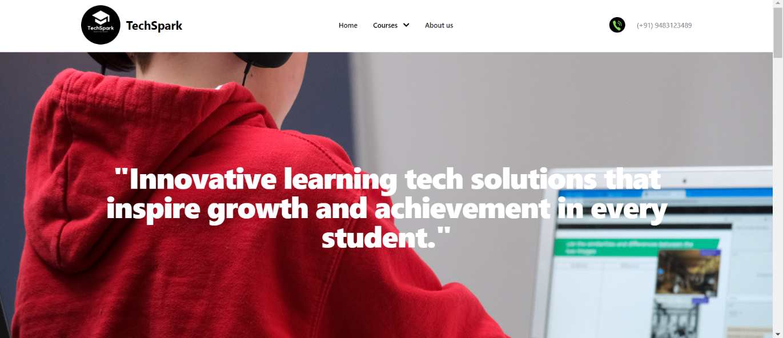

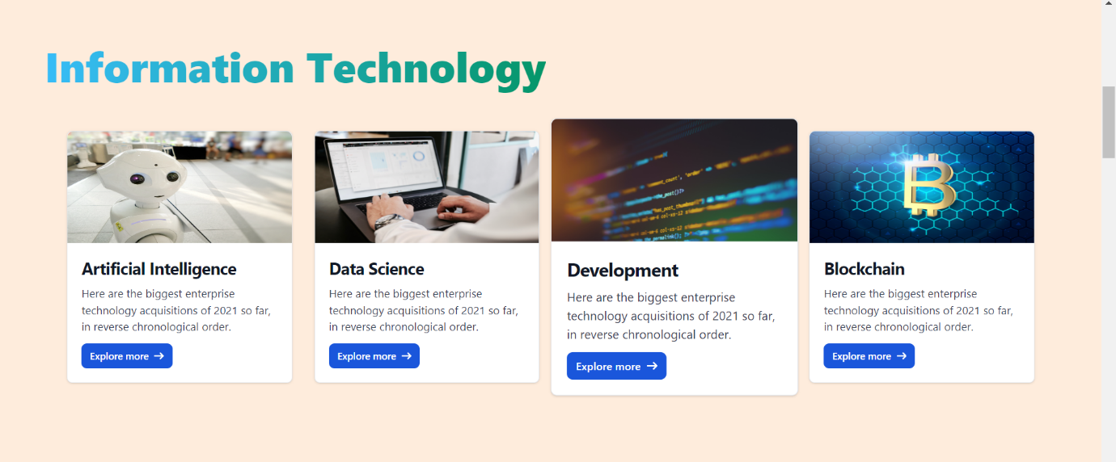

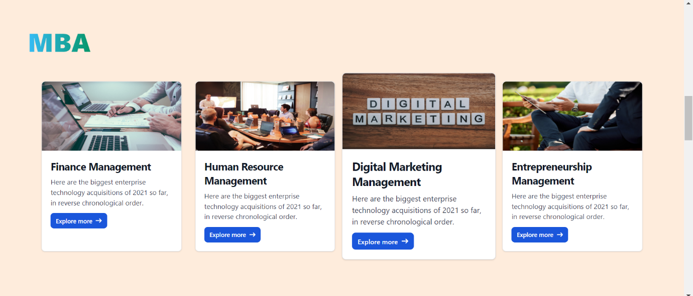

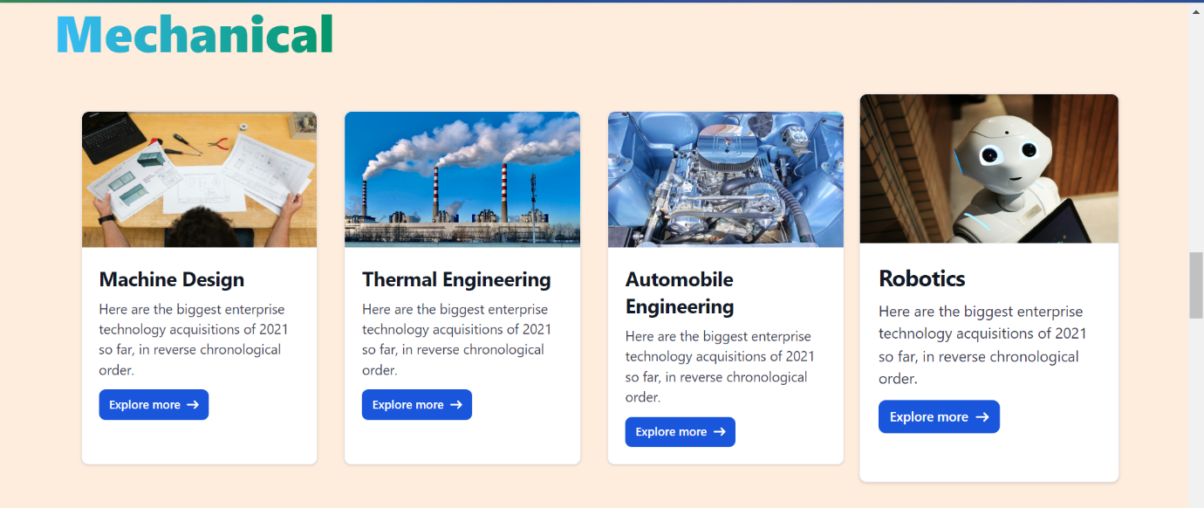

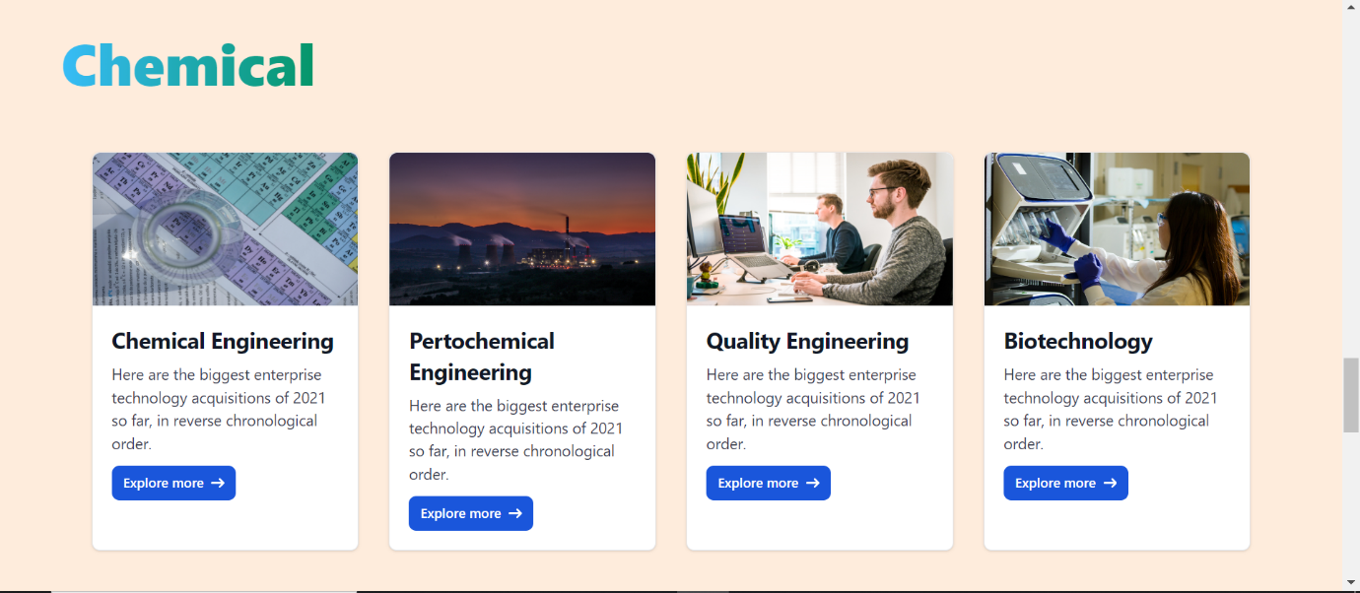

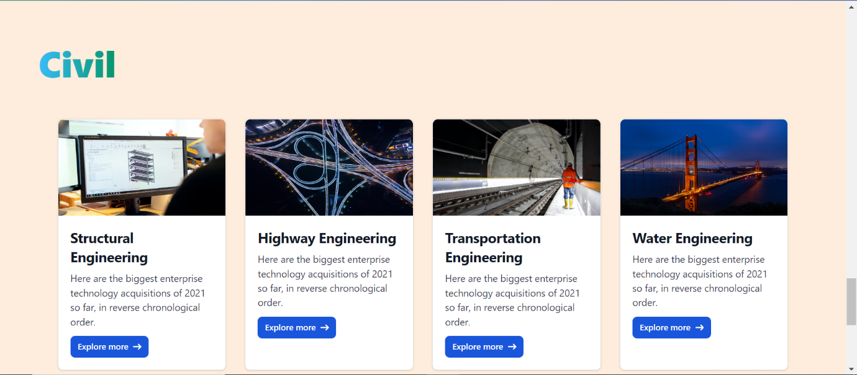

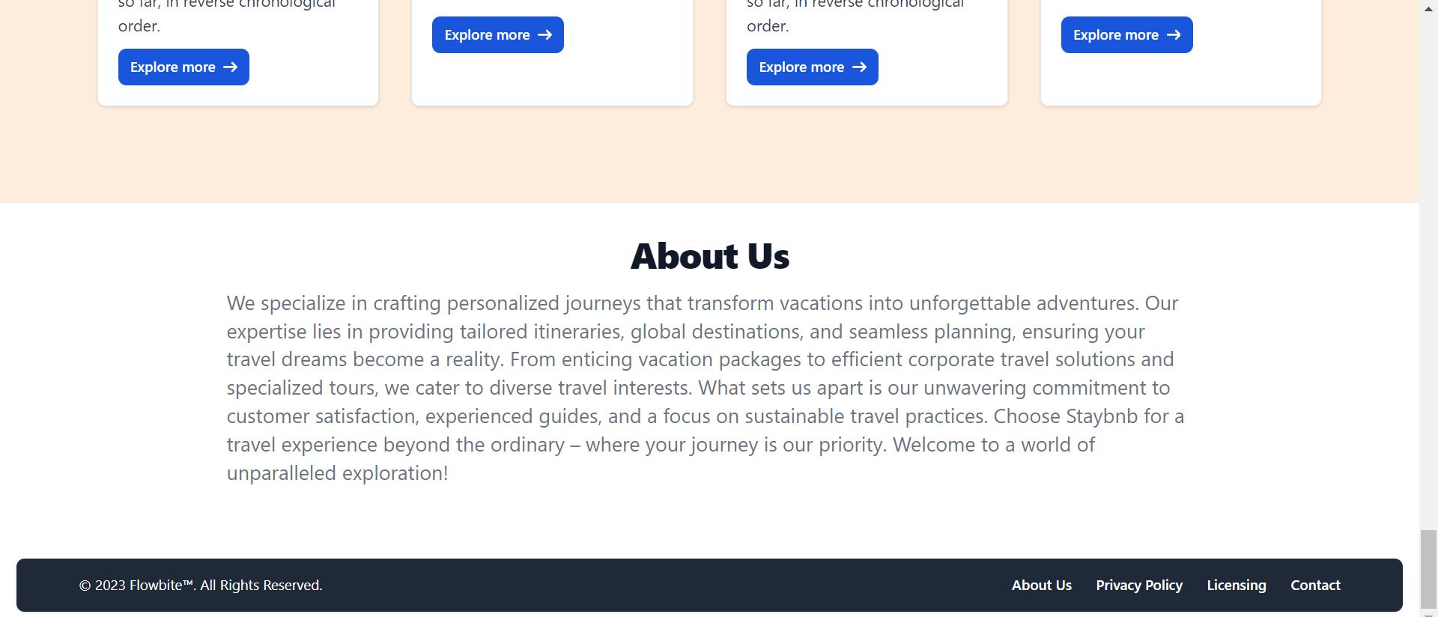

**Image - 2**

In this section , **Information Technology** in which there are different courses. After clicking on the course video gets started.







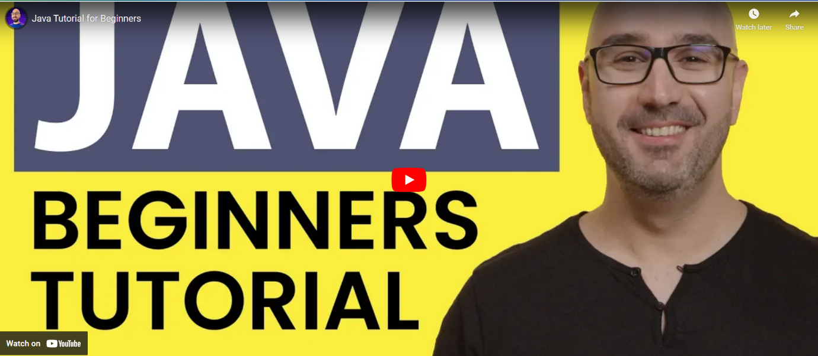

**Image - 3**

In this section , **MBA** in which there are different courses. After clicking on the course video gets started.







